**Task 11: Renewable Resources – Comprehension Topic Test**

**Energy**  
We use a lot of energy to live. Whether we're playing, studying or eating, energy makes these activities possible. We also use energy for automated production, to run the machines in a warehouse for instance. Much of this energy comes from fuels like oil, coal or natural gas. These fuels are used to make the asphalt for roads and the rubber for basketballs. We also use it to generate the electricity for the lights all around you. Think of all the energy required to plant, grow, harvest, transport and cook your lunch, and you can start to understand that energy is a key to life!

Fuels like natural gas, oil and coal are important natural resources. They are known as fossil fuels and take millions of years to form. We've used them for hundreds of years, and they've powered everything from planes and trains to cars and computers. Unfortunately, fossil fuels are non-renewable forms of energy. Our power plants burn them faster than nature makes them, and when they are burned, power plants create emissions harmful to the environment.

**What is renewable energy?**  
Renewable energy is energy that comes from sources that are easily made or naturally replenished (restored) in a short period of time. We can’t run out of renewable energy sources. Some examples of renewable energy include solar, geothermal, wind, and hydropower

**What is solar energy?**  
Solar energy is the light and heat that comes from the Sun. Solar energy can be collected and used as electricity to power lights, appliances, electronics and other things that use electricity. Solar energy is collected by solar panels. Solar panels are big, black panels that are fitted to the roofs of houses and buildings to collect energy. They are becoming very popular in sunny places. See if you can spot some next time you’re going for a walk. Australia will soon be home to the world’s biggest solar farm. This is located in Tennant Creek, Northern Territory and is bigger than 20,000 soccer fields! This solar farm is currently being built and is said to be done in 2027.

Using renewable energy is a good way to reduce our dependence on fossil fuels, though renewable energies have some negative impacts on the earth as well. Solar power plants are usually built in deserts where sunshine is reliable and strong, but the desert land that is disrupted for the construction and operation of these power plants is actually rich with plant and animal life.

**What is wind power?**  
Have you ever seen those huge, white windmills? They are called wind turbines and they harness energy from the wind. Wind farms are lots of those white wind turbines together. The wind turns the blades of the turbine and this powers a generator in the base of the turbine and creates electricity. Wind farms can power entire villages. The bigger the turbine, the more electricity it generates. The largest wind farm in the world is in China. It is called the Jiuquan Wind Power Base and has a whopping 7000 wind turbines. In Australia, the largest wind farm is currently being built. It is called the Macintyre Wind Farm. It is being built in Queensland and will have up to 180 wind turbines.

Wind energy power plants are called wind farms and require a lot of land. Though each turbine only takes up a small area of land, wind farms can easily have hundreds or thousands of turbines. With that many turbines together, their presence can easily affect birds, bats and other wildlife in the area.

**What is hydropower?**  
Hydropower (or hydroelectricity) is also created using a turbine, like wind power. The difference is that, instead of wind, hydropower is generated through running water. The running water makes the turbine blades spin which powers the generator and creates electricity. Australia’s largest hydropower plant is in southern NSW and is called the Snowy Mountains Scheme. It is made up of 9 power stations and 16 major dams, all harnessing the power of water.

Hydropower plants can generate a lot of energy and electricity, but their existence can dramatically alter the environment around them. Many hydropower plants use dams to create the electricity. Fish can be easily blocked by a dam and prevented from swimming to important spawning grounds. Dams can also fail and cause massive flooding. Also, in the event of a drought, the electricity produced could truly be limited to a trickle!

1. Sort the following energy sources into renewable and non-renewable using the table (5 marks)

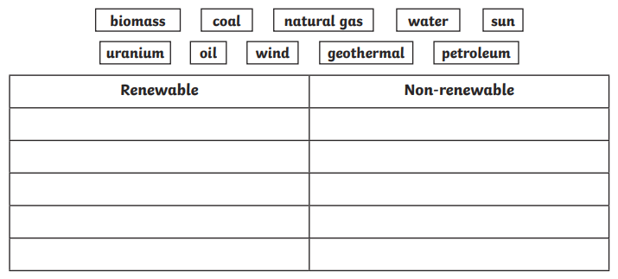

2. Explain the difference between renewable and non-renewable energy. (3 marks)

___________________________________________________________________________

___________________________________________________________________________

___________________________________________________________________________

___________________________________________________________________________

___________________________________________________________________________

3. Justify why you think we as a society still use non-renewable resources. (3 marks)

___________________________________________________________________________

___________________________________________________________________________

___________________________________________________________________________

___________________________________________________________________________

4. For **solar** renewable energy, explain in your own words (4 marks)

i) What is the energy source and how is it collected?

___________________________________________________________________________

___________________________________________________________________________

___________________________________________________________________________

___________________________________________________________________________

ii) What are the environmental impacts of large-scale solar farms?

___________________________________________________________________________

___________________________________________________________________________

___________________________________________________________________________

___________________________________________________________________________

5. For **wind** renewable energy, explain in your own words (4 marks)

i) What is the energy source and how is it collected?

___________________________________________________________________________

___________________________________________________________________________

___________________________________________________________________________

___________________________________________________________________________

ii) What are the environmental impacts of large-scale wind farms?

___________________________________________________________________________

___________________________________________________________________________

___________________________________________________________________________

___________________________________________________________________________

6. For **hydropower** renewable energy, explain in your own words (4 marks)

i) What is the energy source and how is it collected?

___________________________________________________________________________

___________________________________________________________________________

___________________________________________________________________________

___________________________________________________________________________

ii) What are the environmental impacts of large-scale hydropower dams?

___________________________________________________________________________

___________________________________________________________________________

___________________________________________________________________________

___________________________________________________________________________

7. The passage states that it is "important to understand where our energy comes from, how it is produced and what effect each type has on our environment."

Explain why understanding these things is important, using evidence from the passage. (4 marks)

___________________________________________________________________________

___________________________________________________________________________

___________________________________________________________________________

___________________________________________________________________________

___________________________________________________________________________

___________________________________________________________________________

___________________________________________________________________________